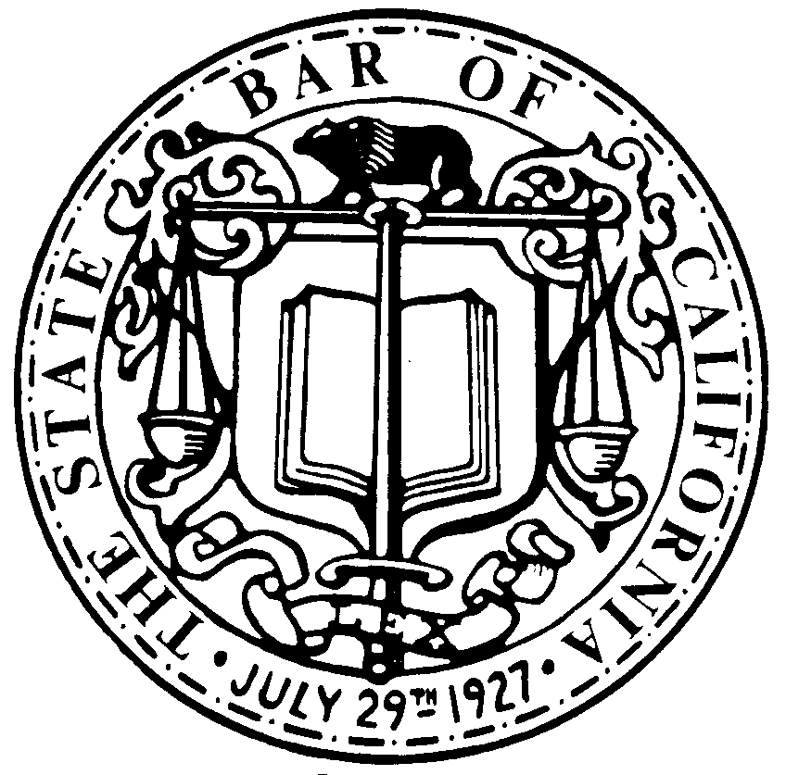
Telephone: 415-538-2252; Fax: 415-538-2389
Email: TrustFundProgram@calbar.ca.gov

LEGAL SERVICES TRUST FUND PROGRAM
180 Howard Street, San Francisco, California 94105-1617

THE STATE BAR
OF CALIFORNIA

Stephanie L. Choy

Managing Director
415-538-2249

Lorna Choy
Sr. Grants Administrator
415-538-2535

Denise Teraoka
Grants Administrator
415-538-2545

Daniel Passamaneck
Grants Administrator
415-538-2403

Robert G. Lee
Sr. Accountant
415-538-2009

TO: NEW APPLICANTS FOR FUNDING IN THE 2014-2015 GRANT YEAR

Application materials for funding from the Legal Services Trust Fund Program in the 2014-2015 grant year will be posted at http://calbar.ca.gov/ioltaapplicationmaterials no later than January 6, 2014. The application forms are Microsoft Word and Excel documents that should be opened and saved before you begin working on them. (Please refer to the posted instructions for using the electronic forms.)

Your hard copy application must be received in the Trust Fund office by 5:00 p.m. on Monday, February 3, 2014. The application package must include a complete set of forms and supporting documentation or information required to explain or clarify the forms, as well as all necessary original signatures in the appropriate spaces. Also enclose one complete, one-sided photocopy of all application forms and explanatory information. Do not provide an extra copy of documents such as your financial statement or reports of monitoring visits by other funding agencies.

Please submit an electronic copy of your application forms in Microsoft Word or Excel format in addition to the hard copy. Electronic or fax copies will not be accepted in lieu of the timely receipt of a fully-executed, original hard copy. Applicants are solely responsible for ensuring that all necessary application materials are submitted and delivered on time.

All application materials received by the Legal Services Trust Fund Program are public records. They are available for inspection upon request and copies of application materials may be transmitted electronically.

Please feel free to contact our office at 415-538-2252 if you have any questions regarding the grant application process.

Sincerely,

/s/

Lorna Choy, Senior Grants Administrator
Legal Services Trust Fund Program

